Dissection Notes

- To fully dissect the nerf gun, the plunger assembly (consisting of parts 1-8) was first removed from the plastic casing by unscrewing the four stainless steel screws connecting the baseplate to the plastic casing.
- A flathead tool was then used to remove the rubber o-ring, rubber seal, and steel rivet on the top of the plastic shaft head of the plunger.
- This, in turn, allowed for three remaining pieces of the plunger assembly, (plastic shaft head, plastic shaft, and plunger assembly spring) to be disassembled.
- Next, a hacksaw was used to split the plastic casing of the gun into two equal parts, and allowed for the removal of the plastic trigger from the housing assembly.
- The segment of the plastic casing with the barrel was then disassembled by removing the barrel spring by hand from its two fixed supports, which in turn, allowed for the barrel back panel to be removed. The last remaining part in the housing assembly, the bullet holder is fixed at one end, and free to rotate into and out of the barrel at the other.

Views of the plunger and housing assemblies along with their associated components in the order in which they are disassembled will be provided in detail below.

Full Dissection

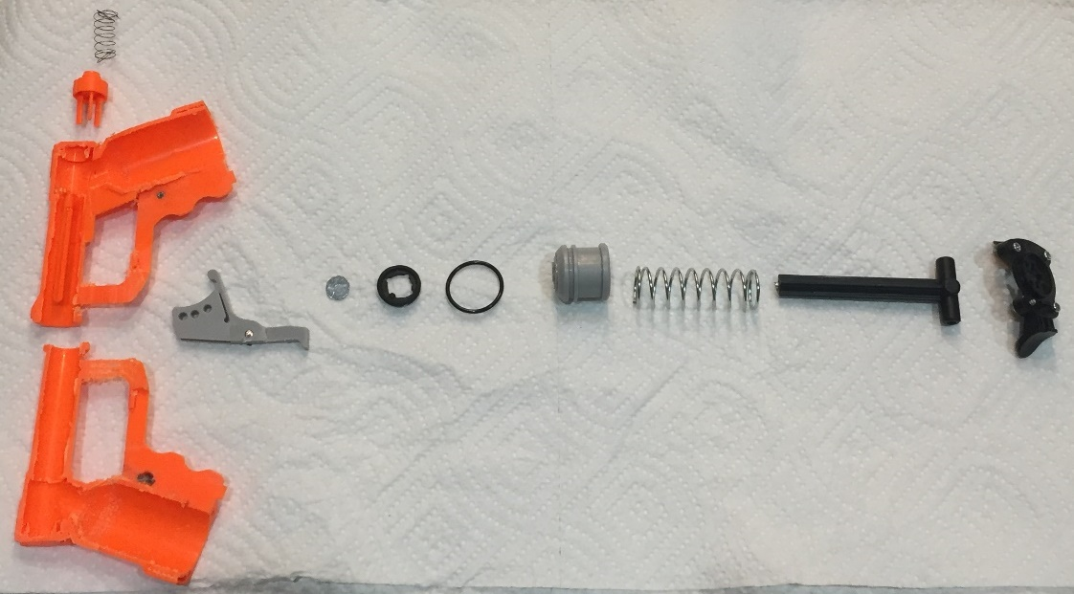
Figure 1: Full Dissection of the Nerf Gun

Plunger Assembly

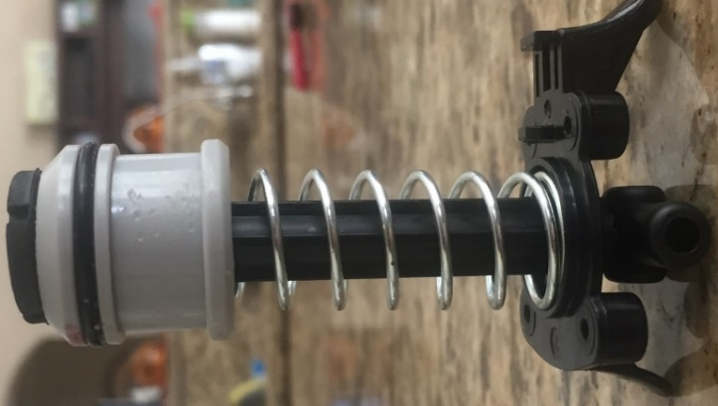
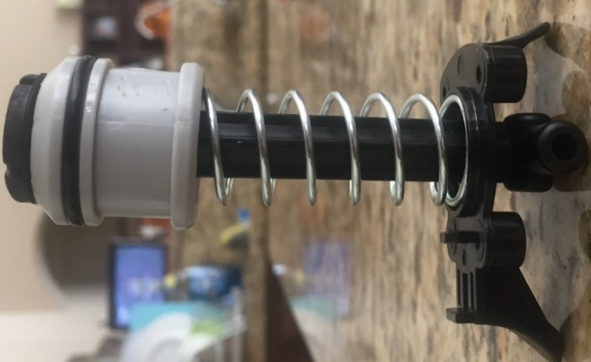
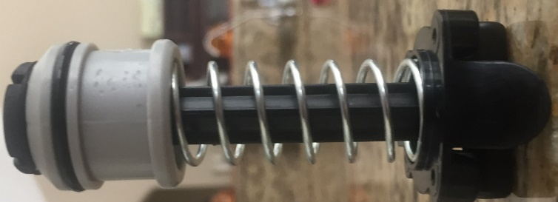
Figure 5: Plunger Assembly (Right View)
Figure 2: Plunger Assembly (Front View)
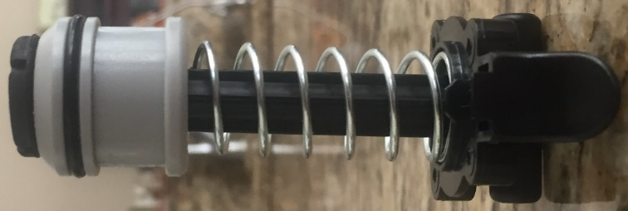

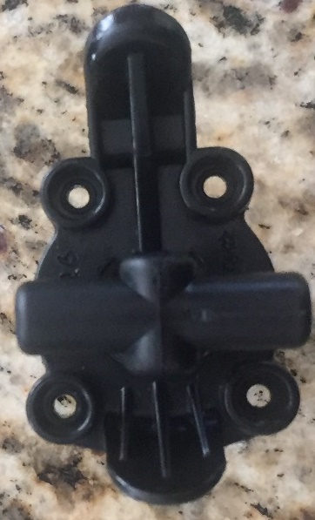
Figure 7: Plunger Assembly (Bottom View)
Figure 4: Plunger Assembly (Left View)

Figure 3: Plunger Assembly (Back View)

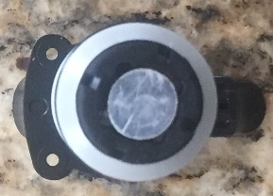

Figure 6: Plunger Assembly (Top View)

Plunger Dissassembly

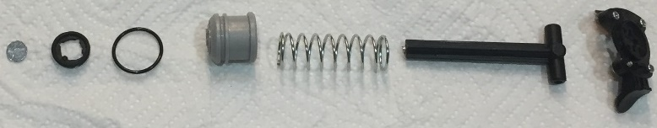
Figure 8: Disassembly of the Plunger

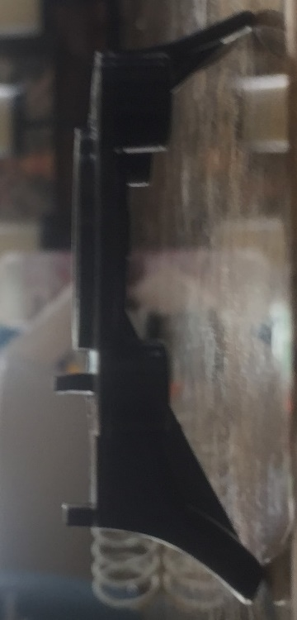
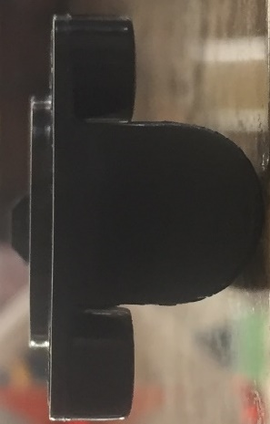
Baseplate
Figure 11: Plunger Assembly Baseplate (Left View)
Figure 9: Plunger Assembly Baseplate (Front View)
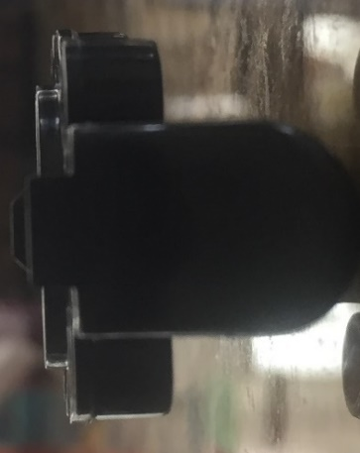
Figure 10: Plunger Assembly Baseplate (Back View)
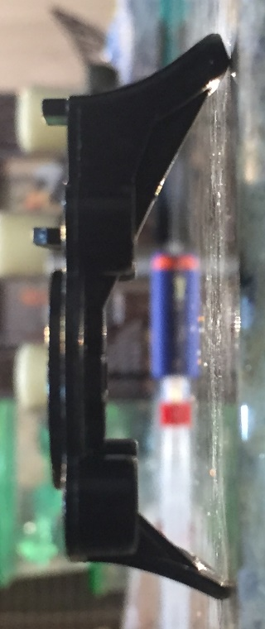
Figure 12: Plunger Assembly Baseplate (Right View)

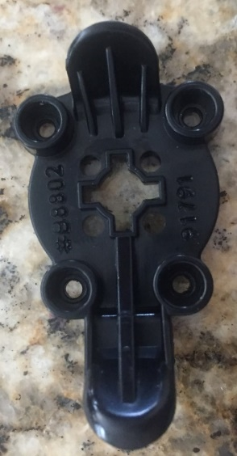
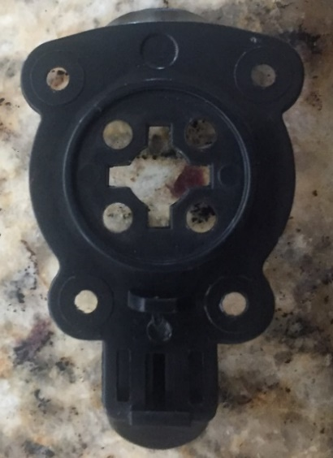
Figure 14: Plunger Assembly Baseplate (Bottom View)
Figure 13: Plunger Assembly Baseplate (Top View)

Phillips Screws
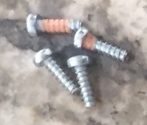
Figure 15: Phillips Screws

Plunger Assembly Shaft

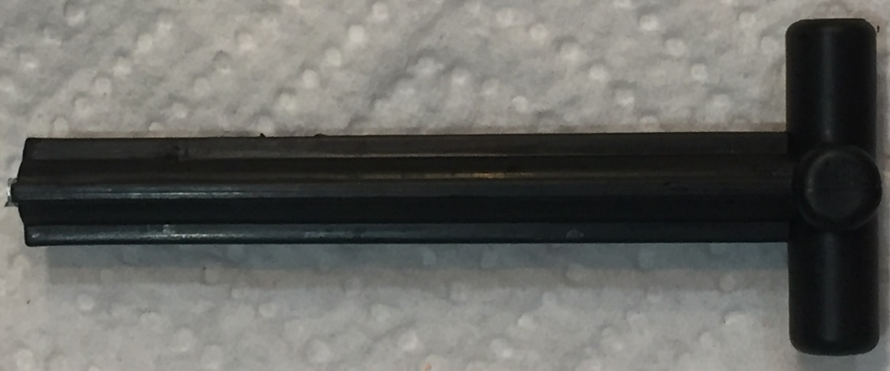
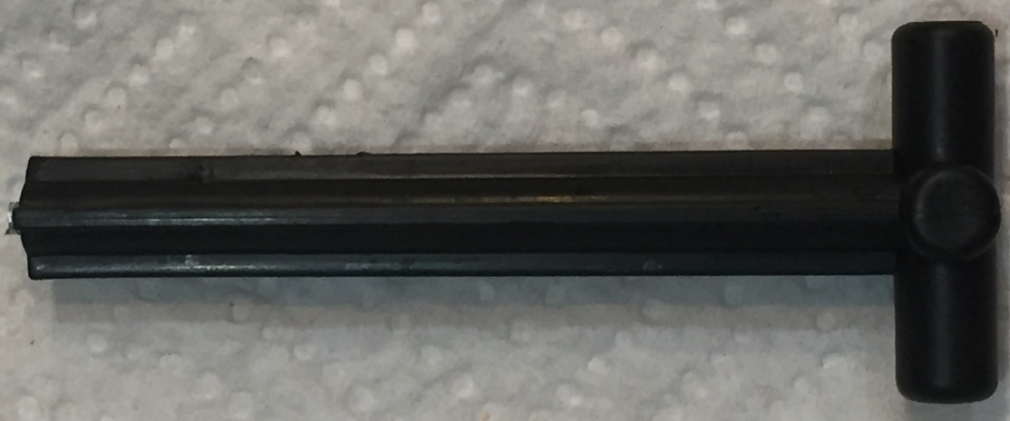
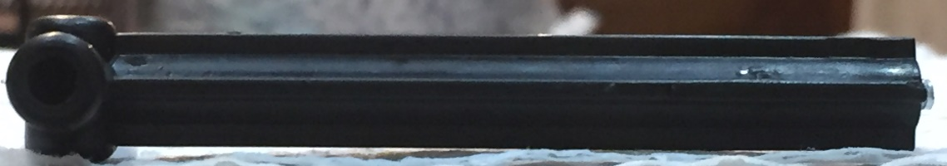
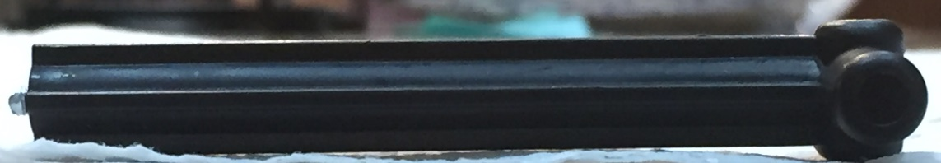

Figure 16: Plunger Assembly Shaft (Front View)
Figure 19: Plunger Assembly Shaft (Right View)

Figure 18: Plunger Assembly Shaft (Left View)

Figure 17: Plunger Assembly Shaft (Back View)

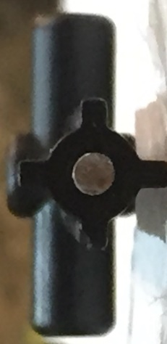
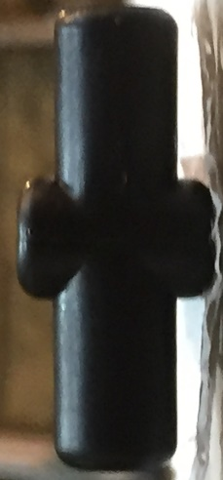
Figure 21: Plunger Assembly Shaft (Bottom View)

Figure 20: Plunger Assembly Shaft (Top View)

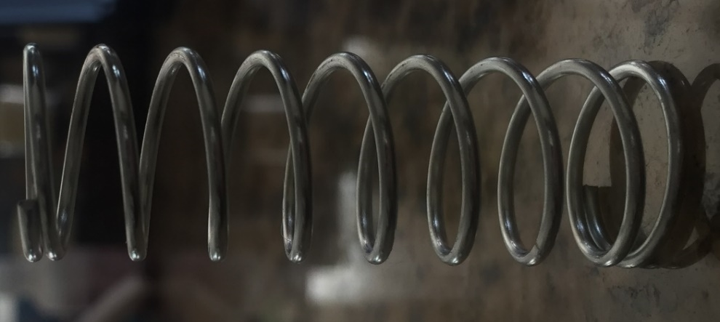
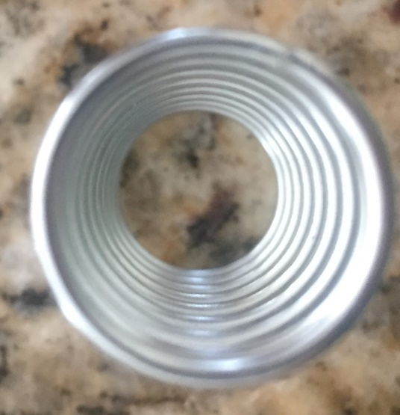
Plunger Assembly Spring
Figure 22: Plunger Assembly Spring (Side View)
Figure 22: Plunger Assembly Spring (Bottom View)
Figure 22: Plunger Assembly Spring (Top View)

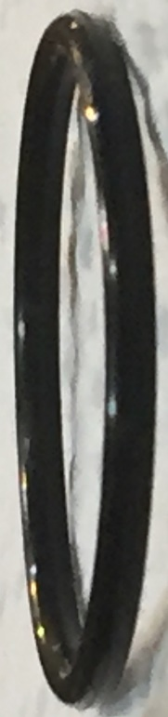
Plunger Assembly Rubber O-Ring
Figure 24: Plunger Assembly Rubber O-Ring (Side View)

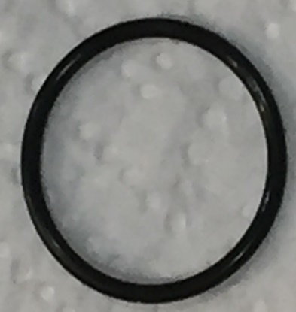
Figure 23: Plunger Assembly Rubber O-Ring (Top View)

Plunger Assembly Rubber Seal

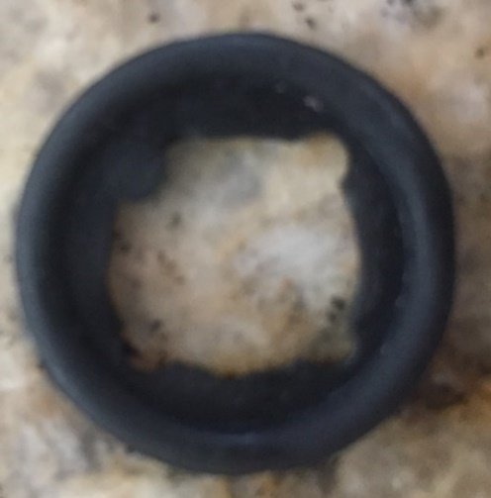
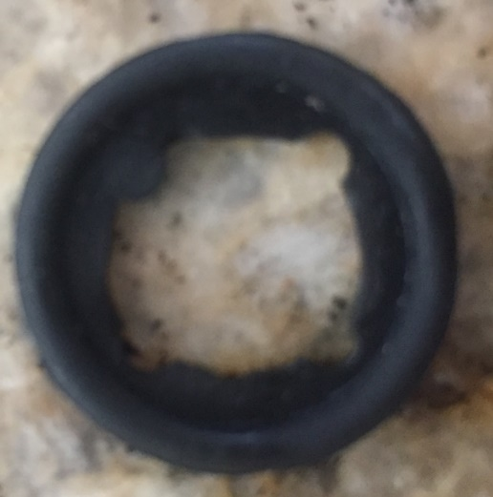
Figure 25: Plunger Assembly Rubber Seal (Top View)
Figure 25: Plunger Assembly Rubber Seal (Bottom View)


Figure 26: Plunger Assembly Rubber Seal (Side View)

Plastic Shaft Head

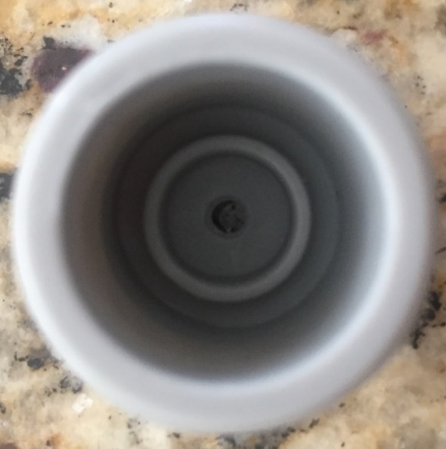
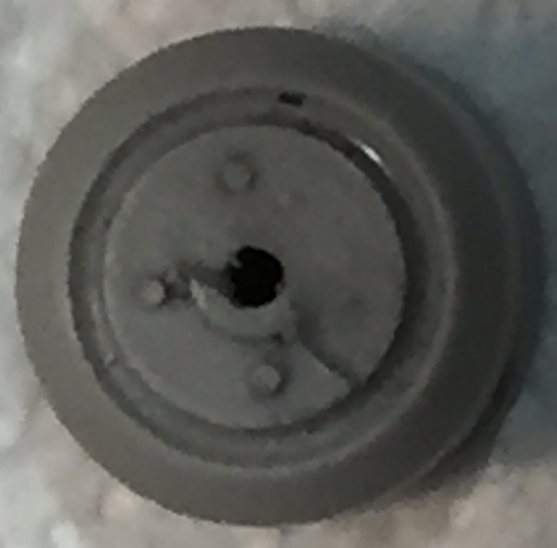
Figure 28: Plunger Assembly Rubber Seal (Bottom View)
Figure 27: Plunger Assembly Plastic Shaft Head (Top View)

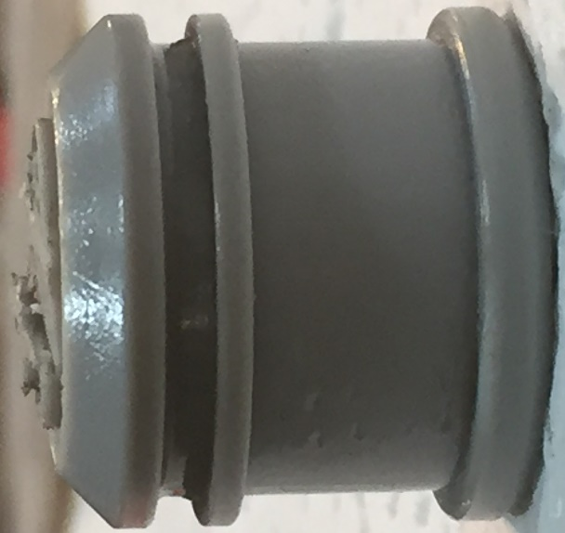
Figure 29: Plunger Assembly Rubber Seal (Side View)

Plunger Assembly Plastic Shaft Head Rivet

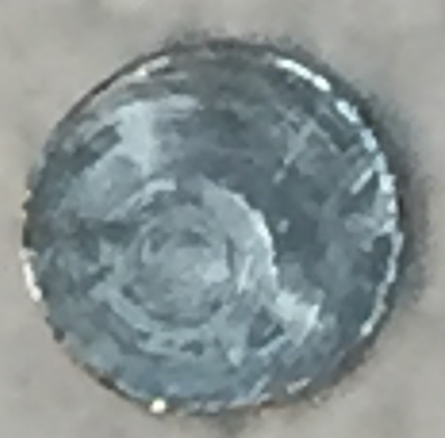
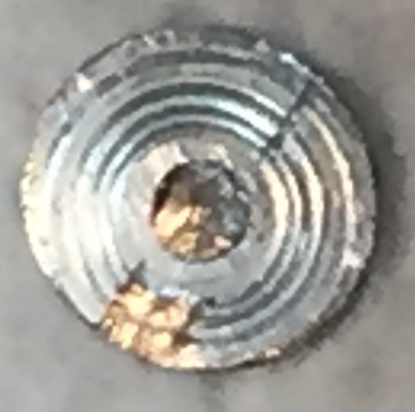
Figure 31: Plunger Assembly Plastic Shaft Head Rivet (Bottom View)
Figure 30: Plunger Assembly Plastic Shaft Head Rivet (Top View)

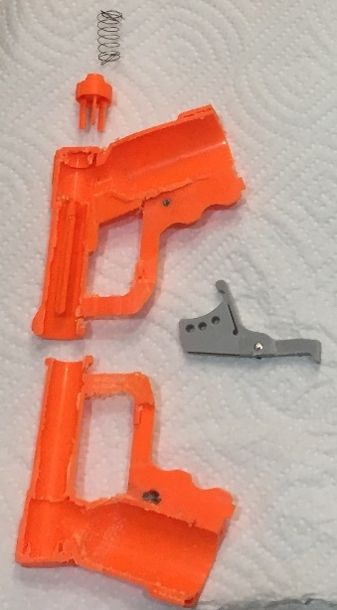
Housing Disassembly
Figure 32: Disassembly of Housing


Housing Assembly Trigger
Figure 33: Housing Assembly Trigger (Front View)
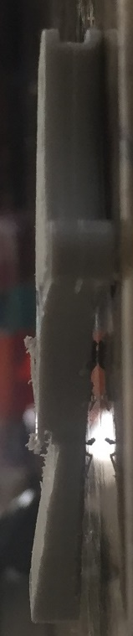
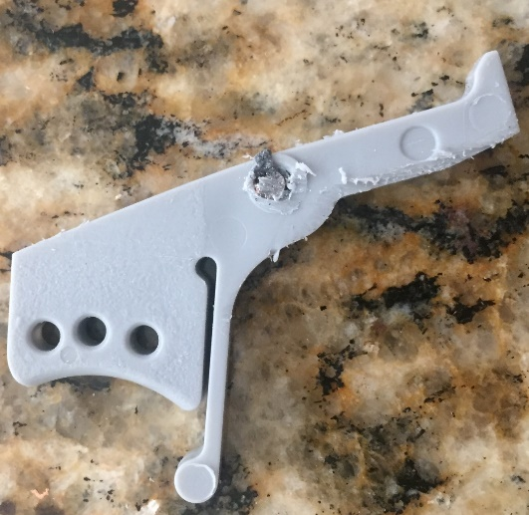
Figure 34: Housing Assembly Trigger (Back View)
Figure 35: Housing Assembly Trigger (Left View)

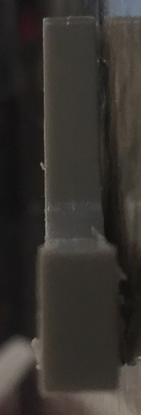
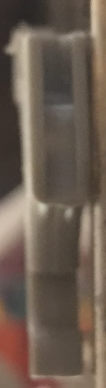
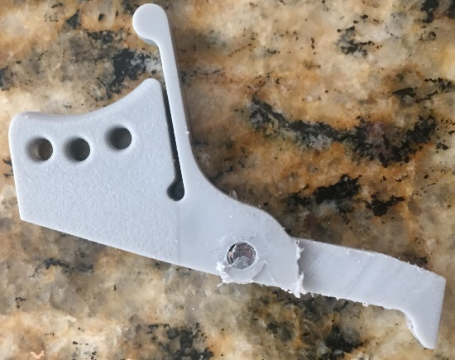
Figure 38: Housing Assembly Trigger (Bottom View)
Figure 37: Housing Assembly Trigger (Top View)
Figure 36: Housing Assembly Trigger (Right View)

Housing Assembly Trigger Rivet
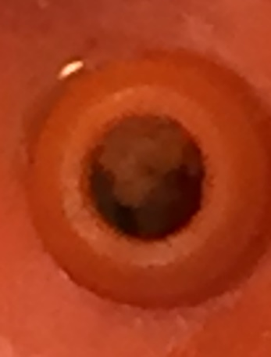
Figure 39: Housing Assembly Trigger Rivet Void (As it appears on Plastic left view of plastic casing)
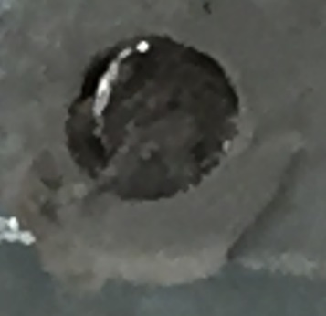
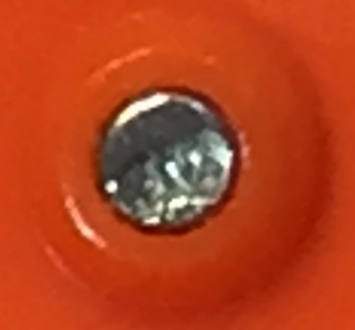
Figure 41: Housing Assembly Trigger Rivet (As it appears on left and right views of trigger)
Figure 40: Housing Assembly Trigger Rivet (As it appears on right view of plastic casing)

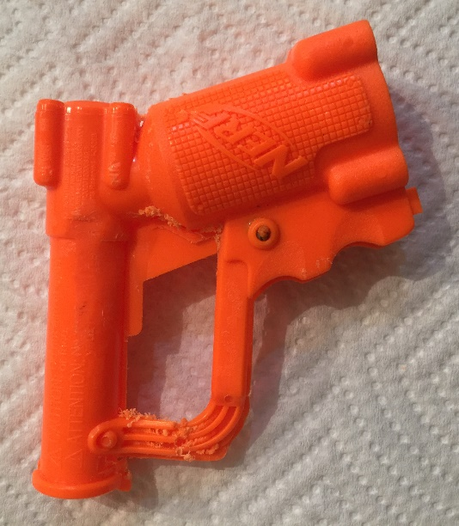
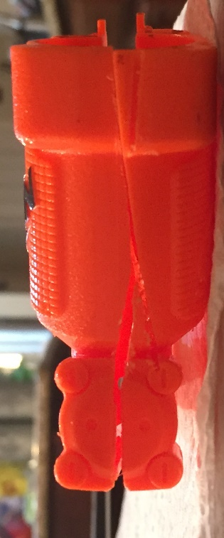
Housing Assembly Plastic Case
Figure 44: Housing Assembly Plastic Case (Left View)
Figure 42: Housing Assembly Plastic Case (Front View)
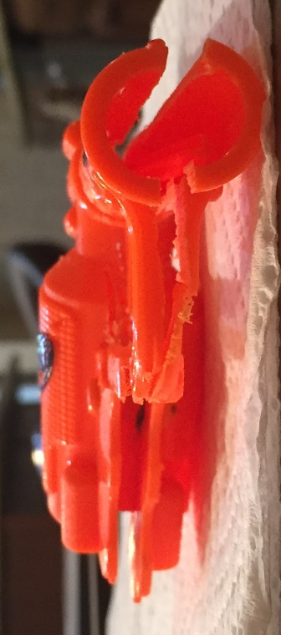
Figure 43: Housing Assembly Plastic Case (Back View)

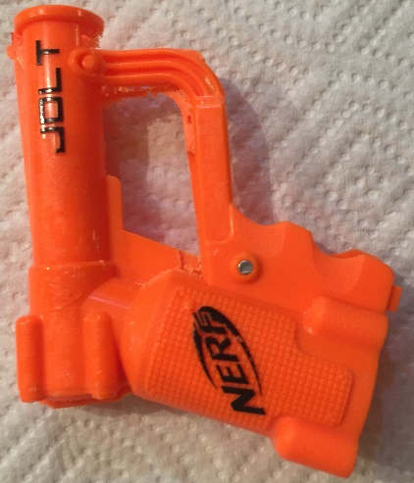
Figure 45: Housing Assembly Plastic Case (Right View)

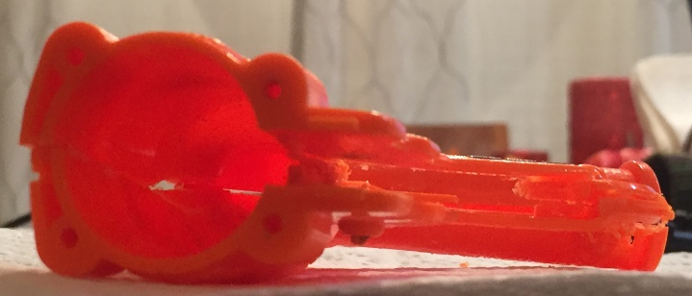
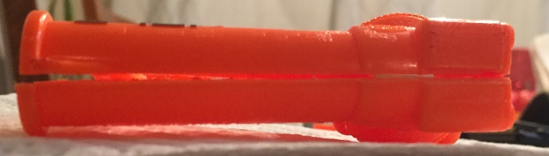
Figure 47: Housing Assembly Plastic Case (Bottom View)
Figure 46: Housing Assembly Plastic Case (Top View)

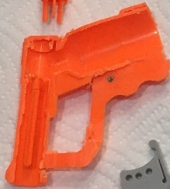
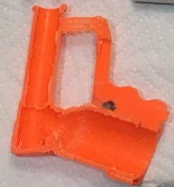
Figure 49: Housing Assembly Plastic Case (View of Inside of Right Segment)
Figure 48: Housing Assembly Plastic Case (View of Inside of Left Segment)

Housing Assembly Barrell Spring
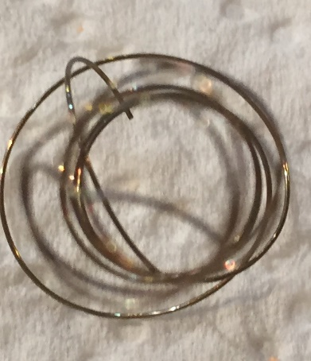
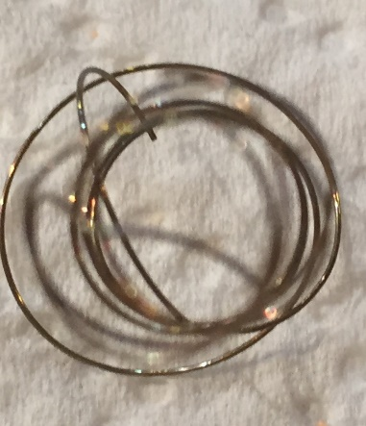
Figure 51: Housing Assembly Barrel Spring (Bottom View)

Figure 50: Housing Assembly Barrel Spring (Top View)
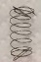
Figure 52: Housing Assembly Barrel Spring (Side View)

Housing Assembly Barrell Back Panel

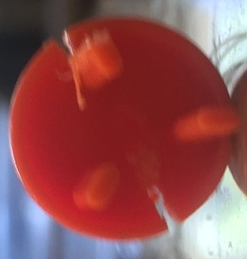
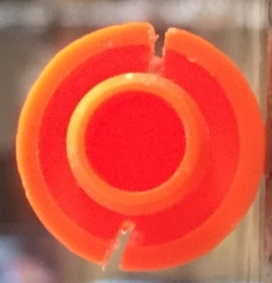
Figure 54: Housing Assembly Barrel Back Panel (Back View)
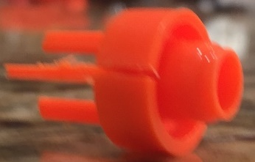
Figure 53: Housing Assembly Barrel Back Panel (Front View)
Figure 55: Housing Assembly Barrel Back Panel (Side View)

Housing Assembly Bullet Holder

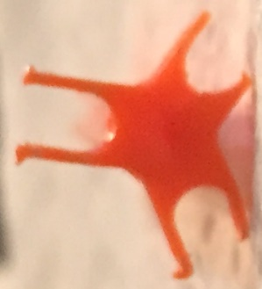
Figure 56: Housing Assembly Bullet Holder (Front View)
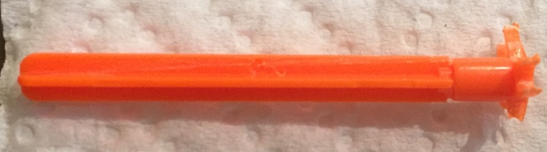
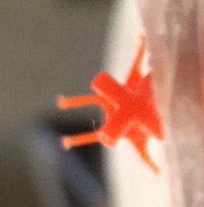
Figure 58: Housing Assembly Bullet Holder (Side View)
Figure 57: Housing Assembly Bullet Holder (Back View)

